電腦視覺 Homework 1 – Basic Image Manipulation

R08922A04 林承德

Original lena.bmp

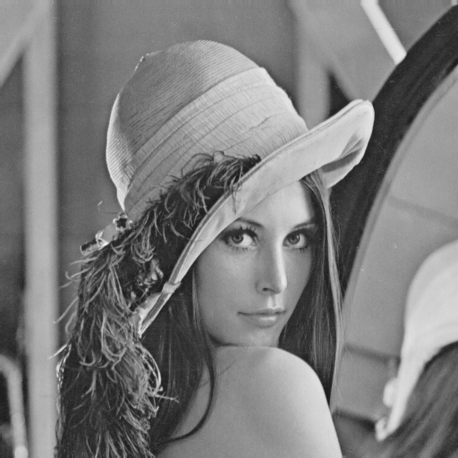

Part1: Write a program to do the following requirement

1. Upside-down lena.bmp

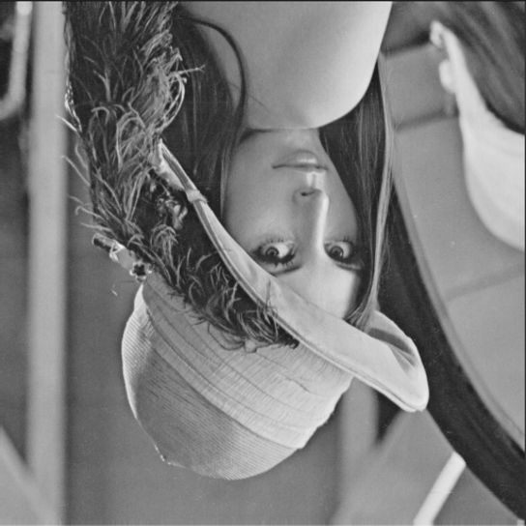

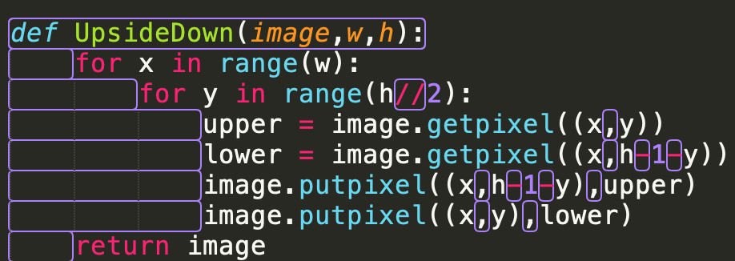

1. Right-side-left lena.bmp

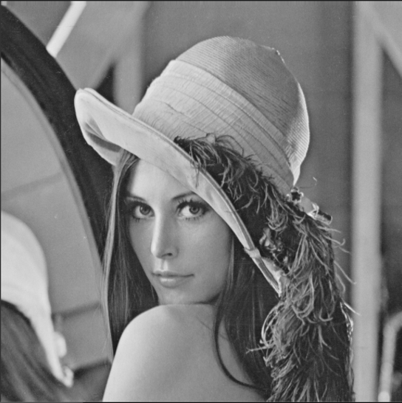

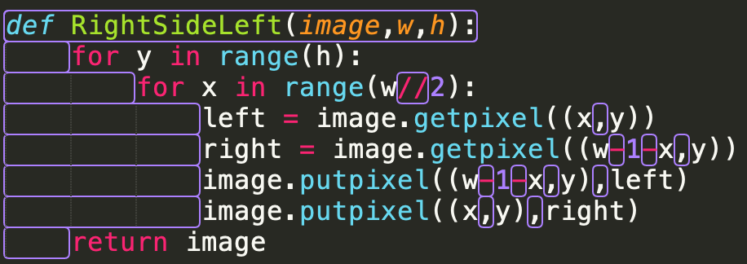

1. diagonally mirrored lena.bmp

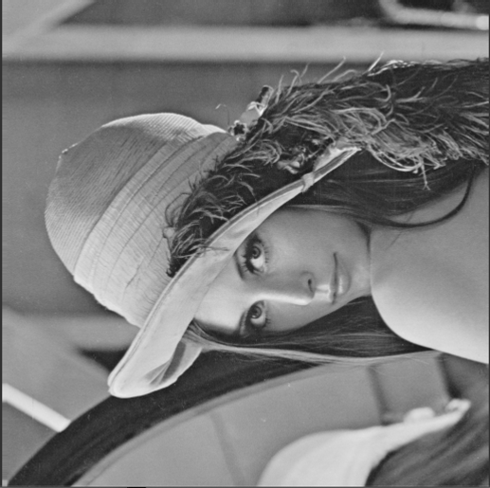

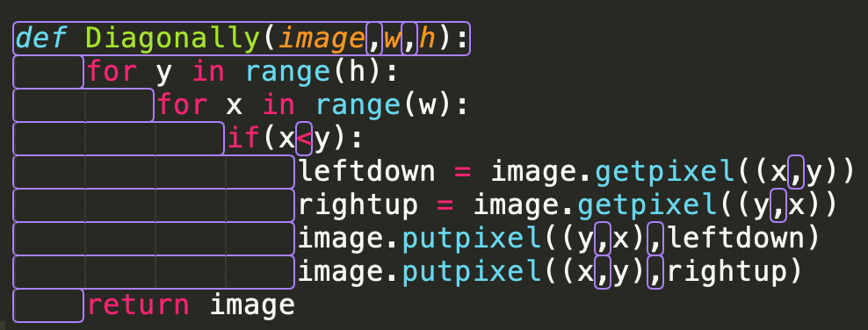

Part2:Write a program or use software to do the following requirement

(Done with photoshop)

1. rotate lena.bmp 45 degree clockwise

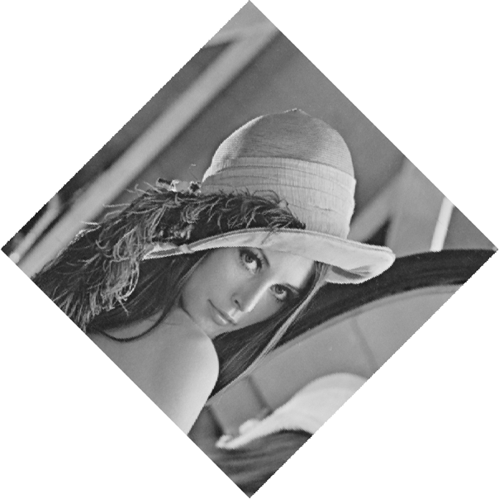

1. shrink lena.bmp in half

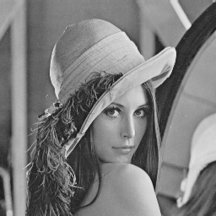

origin

1. Binarize lena.bmp at 128 to get a binary image

